Project Design Phase-II Data Flow Diagram &User Stories

|  |  |
| --- | --- |
| Date | 15 October 2022 |
| Team ID | PNT2022TMID50986 |
| Project Name | Project - IOT Based Personal Assistance for  Senior who are Self-Reliant |
| Maximum Marks | 4 Marks |

Data Flow Diagram

Figure: Data Flow Diagram-IOT Based Personal Assistance for Senior who are Self-Reliant

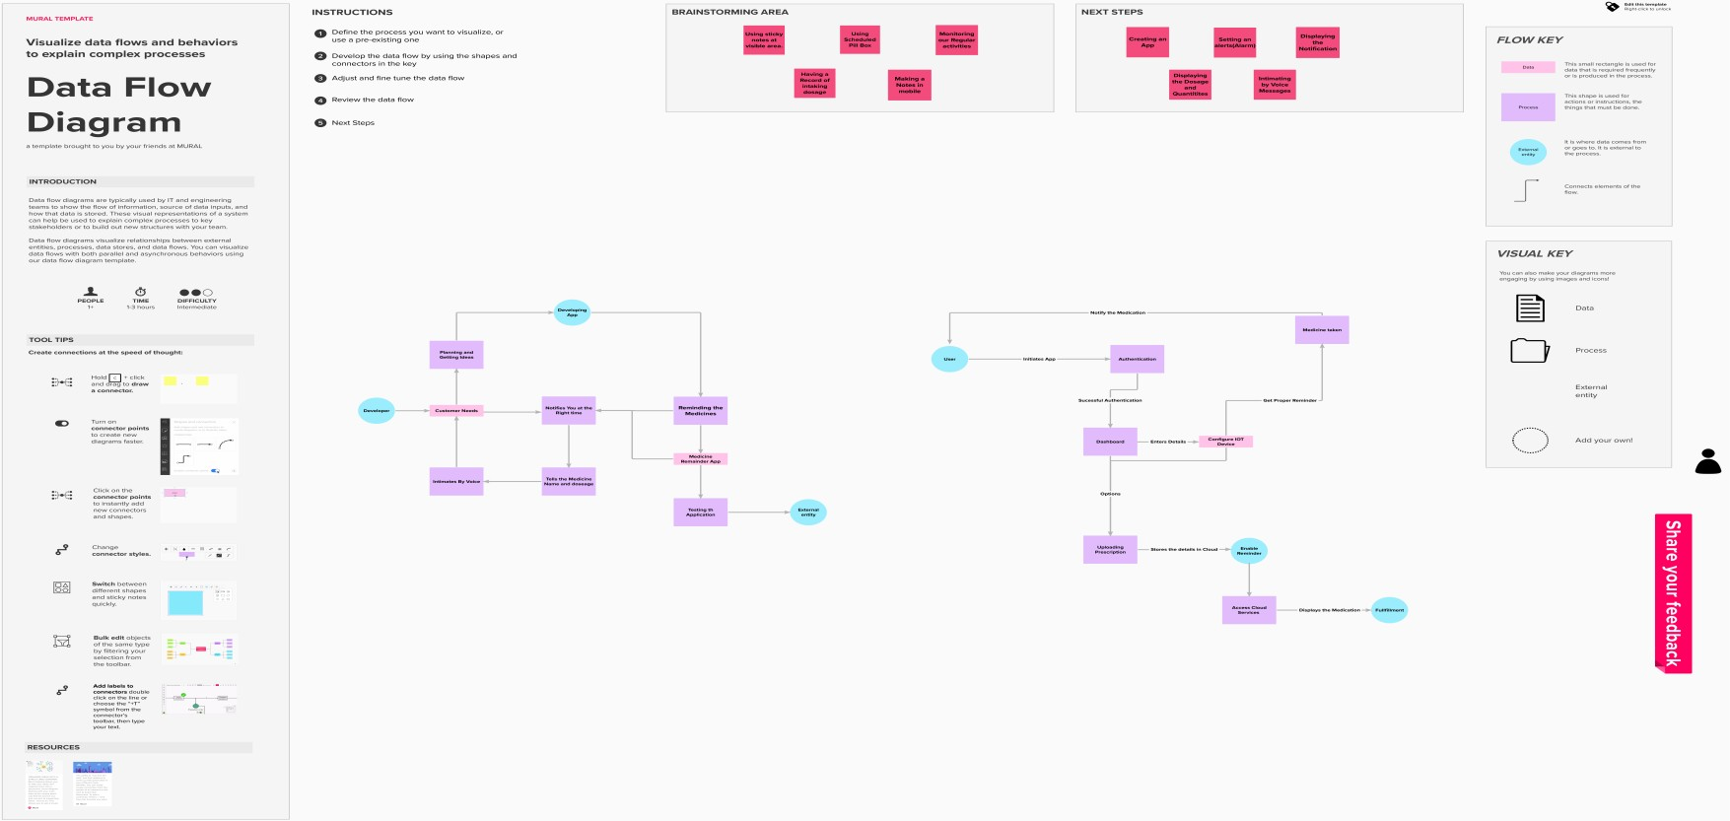

User Stories

User stories for the product:

|  |  |  |  |  |  |  |
| --- | --- | --- | --- | --- | --- | --- |
| **User Type** | **Functional**  **Requirement (Epic)** | **User Story Number** | **User Story / Task** | **Acceptance criteria** | **Priority** | **Release** |
| Customer (Senior Citizen) | Caretaker | USN-1 | As a user, I want to take Medicines on time and monitor my health. | I want to take Medicines on time. | High | Sprint-1 |
| Customer  (Alzheimer Patient) | Smart Medicine Box | USN-2 | As a user, I want to take my tables on time by voice command. | Need to take my tablets on time by voice command. | High | Sprint-1 |
| Customer (Mentally Idle  Patient) | Caretaker | USN-3 | As a user, my patient needs to take medicines on time and monitoring the activity. | My patient needs to take medicines on time. | Medium | Sprint-2 |
| Customer (Paralysed Patient) | Caretaker | USN-4 | As a user, my patient medication time and prescription should load in database for upcoming week. | My patient medication time and prescription should be in database list | Low | Sprint-4 |
| Customer (Handicapped Patient) | Smart Medicine Box | USN-5 | As a user, I need to take my medicine in near by places with light notification. | I need to take my medicine in nearby places with light notification. | Medium | Sprint-3 |